Using msc1

I thought I’d keep a record of unexpected event when using this machine. These might not be problems, but were unexpected.

Starting S-PLUS 6

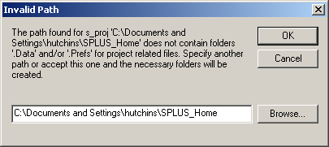

I cancelled because I wasn’t sure what to do.

Using Word

Saving this document:

I decided to save it in the My Documents folder. I thought I’d remove the My Pictures folder & shortcut. This is the error I got when trying to open My Pictures. Why?

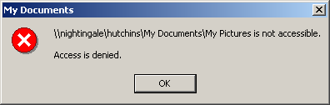

Printing:

How do I print double sided on spr2 or lw? I couldn’t find the duplex options.

Exceed

Is it possible to change the name on the Start menu from Hummingbird Connectivity 7.0 to something more memorable such as Exceed?

Other things:

What are we going to do about the desktop? Will it contain shortcuts to commonly used programs such as Word, S-PLUS, a Command Prompt Window, and Exceed? Do we need Windows Media Player on the desktop?

What is the status of TeX. I wanted to install WinShell, but the instructions suggest that TeXlive needs to be installed. It might be that this isn’t the case, but I don’t want to break anything.

